NFC-IETUNIVERSITY,MULTAN



LAB REPORT

ICT (“Information & Communication TechnologyFundamental”)

For thedegreeofBacheller ofScience

InComputerScience

Session [2k24]

**Name :** Ammara Imran

**Roll NO : (2k24-BSCS-413)**

**Section : Y**

**Submitted To: MS FAIBA HASSAN**

**Submitted By: AMMARA IMRAN**

18October2024

LAB 1

**Typing Practice :**

Typing practice is a way to improve your typing speed, accuracy, and efficiency on a keyboard. It involves using various exercises, tools, and techniques to develop muscle memory and familiarity with key placements.

**Example :**

#### Typing Master is the best software for typing practice as it helps u to increase your typing speed.

**Internal Components of Computer**

**1. Central Processing Unit (CPU)**

* **Purpose**:
* Acts as the "brain" of the computer, executing instructions and performing calculations.
* **Components:**
* **Control Unit (CU):** Directs operations of the processor.
* **Arithmetic Logic Unit (ALU):** Performs mathematical and logical operation.

**2. Motherboard**

* **Purpose:**
* **The main circuit board connecting all components, allowing them to communicate.**
* **Includes: CPU socket, RAM slots, storage connectors, and expansion slots.**

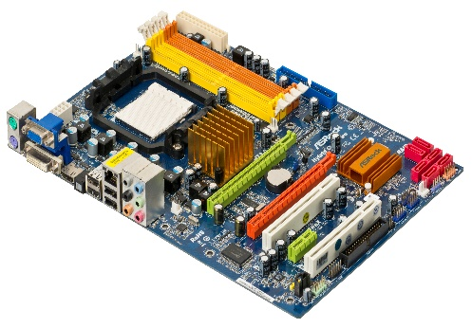

[This Photo](http://commons.wikimedia.org/wiki/file:a790gxh-128m-motherboard.jpg) by Unknown Author is licensed under [CC BY-SA](https://creativecommons.org/licenses/by-sa/3.0/)

**3. Power Supply Unit (PSU):**

* **Purpose:**
* Converts electricity from an outlet into usable power for the computer’s components.
* **Feature:**
* Provides the required voltage and wattage.

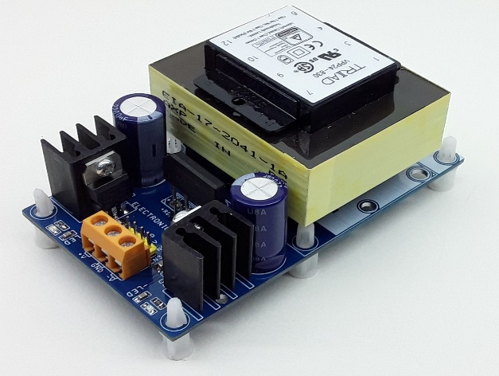

[This Photo](https://www.electronics-lab.com/tag/12v/) by Unknown Author is licensed under [CC BY-SA](https://creativecommons.org/licenses/by-sa/3.0/)

**4. Memory (RAM - Random Access Memory)**

* **Purpose:**
* Temporarily stores data and instructions currently in use by the CPU for quick access.
* **Feature:**
* Volatile memory, meaning data is lost when power is off.

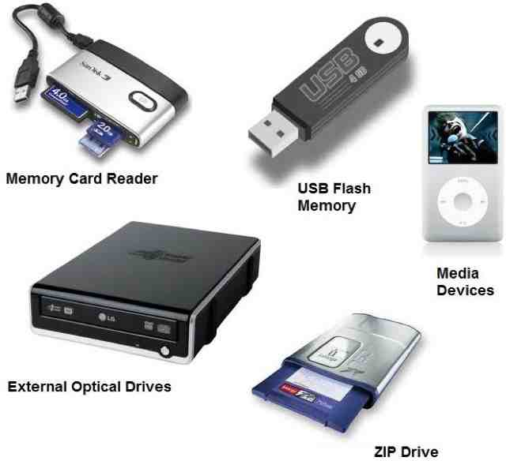

[This Photo](https://tsaponar.blogspot.com/2013/05/) by Unknown Author is licensed under [CC BY-SA](https://creativecommons.org/licenses/by-sa/3.0/)

**LAB 2**

* **Windows installation Steps:**

1. **Prepare:**

* Back up your data.
* Create a bootable USB or DVD with the Windows installer.
* Ensure your PC meets Windows requirements.

1. **Boot from Installation Media:**

* Insert the USB/DVD, restart your PC, and boot from the installation media via BIOS/UEFI settings.

1. **Start Installation:**

* Select language, time, and keyboard preferences.
* Enter the product key (if you have one).

1. **Choose Installation Type:**

* **Upgrade: Keeps files/settings.**
* **Custom: Clean install on a selected partition.**

1. **Install Windows:**

* Wait for files to copy and install. Your PC will restart several times.

1. **Set Up Windows:**

* Configure region, Wi-Fi, and privacy settings.
* Log in with a Microsoft or local account.

1. **Finish Setup:**

* Update Windows, install drivers, and restore files.
* CPU Assembling Steps:
* **Prepare Workspace**:

Use a static-free surface and wear an anti-static wrist strap.

1. **Install CPU**:

* Open the CPU socket on the motherboard.
* Align and place the CPU (gold triangle with socket marker).
* Secure it by lowering the lever.

1. **Apply Thermal Paste**:

Add a pea-sized amount if not pre-applied on the cooler.

3. **Attach CPU Cooler**:

* Place the cooler on the CPU and secure it with screws/clips.
* Connect the fan cable to the "CPU\_FAN" header.

4.**Install RAM**:

Insert memory modules into motherboard slots.

5.**Mount Motherboard**:

Place it in the case and secure it with screws.

6. **Connect Components**:

Attach PSU cables, storage, GPU, and peripherals.

7.**Power On**:

Turn on the PSU and test the setup.

LAB 3

**Motherboard :**

The **motherboard** is the main circuit board in a computer, connecting and facilitating communication between all components. Here's an overview of its **internal structure** and key components:

* **Internal Structure of a Motherboard:**

1. **Central Processing Unit (CPU) Socket**

* **Purpose**:
  + Holds the CPU and connects it to other components.
* **Types:**
  + Vary depending on CPU brand (e.g., Intel LGA or AMD AM sockets).

1. **Chipset**

* **Purpose:** 
  + Acts as a communication hub between the CPU, memory, storage, and peripherals.
* **Components**:
  + - 1. **Northbridge (older motherboards):**
      2. **Southbridge:**

1. **Memory (RAM) Slots:**

* **Purpose**:
  + Holds and connects RAM modules for temporary data storage.
* **Types**:
  + DDR3, DDR4, or DDR5 (depends on motherboard generation).

1. **Expansion Slots (PCI/PCIe)**

* **Purpose**:

Allow installation of additional cards like GPUs, sound cards, or network adapters.

* + **Types**:
    - PCIe x16 (for GPUs)
    - PCIe x1 (for smaller cards)

1. **Storage Interfaces**
   * **Purpose**:

Connect storage devices like SSDs or HDDs.

* + **Types**:
    - SATA ports (for traditional SSDs and HDDs)
    - M.2 slots (for NVMe or SATA SSDs)

1. **Power Connectors**:

* **Purpose**:
  + Distribute power from the PSU to the motherboard and components.
  + **Key Connectors**:
    - 24-pin ATX connector (main power)
    - 8-pin CPU power connector.

1. **BIOS/UEFI Chip**
   * **Purpose**:

Stores firmware for booting and hardware initialization.

1. **I/O Ports and Headers**
   * **Purpose**:

Provide connectivity for external devices.

**Examples**:

## USB ports

## Audio jacks

## Ethernet ports

## Display outputs (e.g., HDMI, VGA).

1. **Integrated Peripherals**

* **Purpose**:

Built-in components for specific tasks.

* Examples:

## Onboard audio chips for sound.

## Network Interface Controller (NIC) for internet connectivity.

1. **Cooling System Connectors :**

* **Purpose**:

Provide power to fans and cooling systems.

Includes headers like **CPU\_FAN** and**SYS\_FAN**.

1. **Internal Buses :**

* **Purpose**:

Data pathways connecting components for communication.

Includes front-side bus (FSB), memory bus, and PCIe lanes.

1. **CMOS Battery**

* **Purpose**:

Powers the BIOS to maintain system settings like time and date.

LAB 4

**Microsoft Office :**

**Microsoft Office** is a suite of productivity tools for creating documents, spreadsheets, presentations, and more. Here's a concise overview:

* **Main Applications:**

1. ***Word:***

*For text editing, document creation, templates, and collaboration tools.*

1. ***Excel:***

*For data analysis with formulas, charts, and PivotTables.*

1. ***PowerPoint****:*

*For presentations with multimedia, animations, and templates.*

1. ***Outlook:***

*For email, calendar, and task management.*

1. ***Access****:*

*For creating and managing databases.*

1. ***OneNote****:*

*For digital note-taking and organization.*

1. ***Teams****:*

*For communication, video conferencing, and file sharing.*

* **Key Features:**
* **Cloud Integration:**

Access and sync files via OneDrive.

* **Collaboration**:

Real-time editing and sharing.

* **Templates**:

Pre-designed layouts for quick, professional results.

* **Security**:

Data encryption and password protection.

* **Automation**:

Macros and tools to save time.

* **Benefits**:

Boosts productivity, easy to use, and works across devices.

**Microsoft Word:**

**Microsoft Word** is a word processing application used for creating, editing, and formatting documents.

* **Key Features of MS Word:**

1. **Text Formatting**:
   * Customize font style, size, color, and spacing.
   * Bold, italic, underline, and strikethrough options.
2. **Paragraph Formatting**:
   * Alignment (left, center, right, justify).
   * Line spacing, indentation, and bullet/numbered lists.
3. **Styles and Themes**:
   * Predefined styles for headings, subheadings, and body text.
   * Document themes for a consistent look.
4. **Templates**:
   * Ready-made templates for resumes, letters, reports, and more.
5. **Insert Objects**:
   * Add images, shapes, charts, tables, and text boxes.
   * Insert hyperlinks, footnotes, headers, and footers.
6. **Collaboration Tools**:
   * Track changes and add comments for collaborative editing.
   * Real-time co-authoring when saved in OneDrive or SharePoint.
7. **Spelling & Grammar Check**:
   * Automatic spelling and grammar correction with suggestions.
   * Thesaurus and translation tools.
8. **Table of Contents**:
   * Automatically generate a table of contents based on document headings.
9. **Review and Editing Tools**:
   * Track changes and accept/reject edits.
   * Compare and merge documents.
10. **Mail Merge**:
    * Create personalized letters, labels, or envelopes by merging data from a spreadsheet.
11. **Cloud Integration**:
    * Save and access documents from OneDrive for online access and sharing
12. **Accessibility Features**:
    * Read aloud, dictation, and translation tools.
    * Accessibility checker to ensure document inclusivity.
13. **Smart Lookup**:
    * Provides definitions, Wikipedia entries, and web searches for highlighted text.

**Benefits:**

* Powerful document creation and formatting tools.
* Collaboration and cloud-based access.
* Widely compatible and professional results.

### LAB 5

* 1. **Mail Merge:**
* **Purpose**:

Automates the creation of personalized documents (e.g., letters, labels) using data from an external source (like Excel).

* + **Steps**:
* **Start Mail Merge**:

Go to **Mailings > Start Mail Merge** and select the document type (e.g., Letters).

* **Select Recipients**:

Click **Select Recipients** to choose a data source (Excel file, CSV, etc.).

* **Insert Merge Fields**:

Place placeholders like name or address using **Insert Merge Field**.

* **Finish & Merge**:

Complete the merge by clicking **Finish & Merge**, then select **Print** or **Create New Document**.

* 1. **Table of Contents (TOC):**
* **Purpose**:

Automatically creates a TOC based on the headings in the document.

**Steps**:

* **Apply Heading Styles**:

Use **Heading 1**, **Heading 2**, etc., for section titles.

* **Insert TOC**:

Go to **References > Table of Contents** and choose a style.

* **Update TOC**:

After changes, right-click the TOC and select **Update Field** to reflect edits.

**3. Section Breaks**

**Purpose**:

Divides a document into sections, allowing different formatting, headers/footers, and page numbering within the same document.

* **Types of Section Breaks**:
* **Next Page**:

Starts a new section on the next page.

* **Continuous**:

Starts a new section on the same page.

* **Odd/Even Page**:

Starts a new section on the next odd/even page.

* **Steps**:
* **Go to Layout > Breaks**, then choose the type of **Section Break**.
  1. **References**
* **Purpose**:

Adds citations, footnotes, endnotes, and bibliographies to a document.

* **Steps**:
* **Insert Citation**:

Go to **References > Citations & Bibliography**, then click **Insert Citation** and choose your source.

* **Add Footnotes/Endnotes**:

Click **Insert Footnote** or **Insert Endnote** under the **References** tab.

* **Manage Sources**:

Use **Manage Sources** to store and organize references for future use.

**5. Headers and Footers**

* **Purpose**:

Adds content that appears at the top (header) or bottom (footer) of each page (e.g., page numbers, document title, author name).

* **Steps**:
* **Insert Header/Footer**:

Go to **Insert > Header** or **Insert > Footer**, and choose a style.

* **Edit Content**:

You can insert text, page numbers, date, or images.

* **Different Headers/Footers for Sections**:

Use **Link to Previous** to enable or disable the same header/footer across sections. To edit a specific section, uncheck **Link to Previous** under the **Header & Footer Tools** tab.

* **Page Numbering**:

Click **Page Number** under the **Insert** tab to place page numbers in headers/footers.

* **Efficient Usage Tips:**
* **Mail Merge**:

Always use an Excel spreadsheet for organizing recipient data and ensure it’s formatted properly before starting the merge.

* **TOC**:

To get the best results, consistently apply heading styles for all section titles in your document.

* **Section Breaks**:

Use them when you need different page orientations (portrait vs. landscape) or separate page numbering formats (e.g., Roman numerals for front matter, numbers for the rest).

* **References**:

Use **Source Manager** to keep a library of citations for future use, and select the correct citation style (APA, MLA, etc.) under **References > Style**.

* **Headers/Footers**:

For documents with multiple sections, ensure each section has the correct header/footer by checking the **Link to Previous** option.

**LAB 6**

### ****1. Mendeley (Reference Management and Citation Tool):****

**Purpose**:

Mendeley helps manage and organize your research papers, create citations, and generate bibliographies.

**Features**:

* **Reference Management**:

Import research papers from academic databases like Google Scholar, JSTOR, and more.

* **Citations**:

Automatically generate citations in various formats (APA, MLA, Chicago, etc.).

* **Bibliography Generation**:

Create bibliographies by selecting references in your Mendeley library.

* **Collaboration**:

Share references and documents with teams for collaborative work.

**Steps**:

1. **Install Mendeley**:

Download and install Mendeley Desktop from [Mendeley’s website](https://www.mendeley.com).

1. **Add Documents**:

Import PDFs or manually add references using the "Add Document" option.

1. **Use Mendeley with Word**:

Install the Mendeley Word Plugin to easily insert citations and generate bibliographies.

* + **Insert Citations**:

Click **References > Insert Citation** and search your Mendeley library.

* + **Generate Bibliography**:

Once all citations are added, Mendeley can create a bibliography with the **Insert Bibliography** button.

### ****2. Grammarly (Grammar and Writing Assistance)****

**Purpose**:

Grammarly helps with grammar checking, spelling correction, style improvement, and plagiarism detection.

**Features**:

* **Grammar Check**:

Checks for spelling, grammar, punctuation errors, and clarity.

* **Writing Style**:

Suggestions to improve sentence structure and readability.

* **Plagiarism Detection**:

Checks if content matches sources online.

* **Tone Detection**:

Analyzes the tone of your writing (formal, casual, etc.).

**Steps**:

1. **Install Grammarly**:

Download the Grammarly plugin for your browser, or use the desktop app.

1. **Use in Word**:

Grammarly integrates with Microsoft Word and Outlook to check grammar while you write.

1. **Proofread**:

Review suggestions in the Grammarly sidebar and accept/reject them as needed.

### ****3. PDF Element (PDF to Word Conversion Tool)****

**Purpose**:

PDF Element allows for PDF editing and converting PDFs into Word, Excel, PowerPoint, and more.

**Features**:

* **PDF to Word**:

Convert PDFs into editable Word documents without losing formatting.

* **Editing PDFs**:

Add, delete, or modify text and images in PDFs.

* **Form Filling**:

Fill out PDF forms and save them.

* **OCR (Optical Character Recognition)**:

Convert scanned documents into editable formats.

**Steps**:

1. **Install PDF Element**: Download and install PDF Element from Wondershare's website.
2. **Convert PDF to Word**:
   * Open the PDF in PDF Element.
   * Click on **Convert** and select **To Word**.
3. **Edit PDF**:

Use the **Edit** tab to modify text, images, or add annotations.

1. **OCR**:

If the PDF is a scanned image, use the **OCR** feature to extract editable text.

### ****4. Automating Repetitive Tasks with Macros in Word****

**Purpose**:

Macros automate repetitive tasks in Word, saving time on tasks like formatting, text insertion, etc.

**Steps to Create a Macro**:

1. **Record a Macro**:
   * Go to **View > Macros > Record Macro**.
   * Name your macro and assign a shortcut key.
   * Perform the tasks you want to automate (e.g., formatting text, inserting headers).
2. **Stop Recording**:
   * After completing the actions, click **View > Macros > Stop Recording**.
3. **Run a Macro**:
   * To run your macro, use the shortcut key or go to **View > Macros > View Macros**, select your macro, and click **Run**.

### ****5. Referencing Tools for Citations, Footnotes, and Endnotes****

**Purpose**:

These tools help you create proper citations, footnotes, and endnotes within Word documents.

**Steps**:

* **Insert Citations**:
  1. Use **References > Citations & Bibliography** to insert citations from your selected referencing style.
  2. Click **Insert Citation** to choose or add a source.
* **Insert Footnotes/Endnotes**:
  1. Go to **References > Insert Footnote** to insert footnotes.
  2. For endnotes, click **Insert Endnote**. Both footnotes and endnotes will be numbered automatically.
* **Manage Sources**:

Use **Manage Sources** to store and edit your citations for future use in documents.

**PRACTICAL WORK OF MS WORD FEATURES PERFORMED IN LAB**

***Home 🡪 create a new document , Recent and pinned projects***

***New🡪 ctrl +N (for new blank document)***

***Open 🡪 ctrl + O (opening a new document)***

***Info 🡪 (tells us about privacy related to created document)***

***Save 🡪 ctrl +S (saving document)***

***Save as 🡪 ctrl +S (saving document)***

***Print 🡪 ctrl +P (for printing a document)***

***Share 🡪 (for sharing a document)***

***Export🡪Export as PDF***

***Close 🡪 for closing document and this time saving name of document by default appears***

***More 🡪 Account and other options***

***Microsof***

**FIRST Group : Clipboard**

**Cut 🡪 ctrl + X (to cut a text)**

**Copy 🡪 ctrl + C (to copy the text)**

**Past 🡪 ctrl + V**

**Format Painter 🡪 we can** format**text**

**Second Group :**Font

Clear formatting

Bold 🡪 **ctrl + B**

Underline 🡪**ctrl + U and**

Italic 🡪***ctrl + I***

Font style🡪**(youaretheone )**

**Font size 🡪 Me**

Strikethrough🡪~~delete~~

Superscript and subscript 🡪 x12 x12

|  |  |  |  |  |
| --- | --- | --- | --- | --- |
| 1 | 2 | 3 | 4 | 5 |
|  |  |  |  |  |

**THIRD Group 🡪Paragraph**

* Left Alignment 🡪ctrl + L
* Right Alignment 🡪 ctrl + R
* centered 🡪 ctrl + E
* justified 🡪 ctrl + J

**Alignment :**

it is difficult to do but its ok as we can do it and I wo should remember to do our work on time and with extra efforts and fully concentration . Lab work is really very exciting and entertaining.

**Bullets :**

* Left Alignment🡪ctrl + L
* Right Alignment🡪 ctrl + R
* centered🡪 ctrl + E
* justified🡪 ctrl + J

**Numbering :**

1. open
2. color
3. grapes

**Sorting :**

**Drum**

**Guitar**

**Piano**

Line Spacing :

**Try try again till you succeed**

**You are the one**

Editing:

### Find

### Replace

### Select

|  |  |  |  |  |  |  |
| --- | --- | --- | --- | --- | --- | --- |
| December | | | | | | |
| M | T | W | T | F | S | S |
|  |  |  |  |  |  | 1 |
| 2 | 3 | 4 | 5 | 6 | 7 | 8 |
| 9 | 10 | 11 | 12 | 13 | 14 | 15 |
| 16 | 17 | 18 | 19 | 20 | 21 | 22 |
| 23 | 24 | 25 | 26 | 27 | 28 | 29 |
| 30 | 31 |  |  |  |  |  |
|  |  |  |  |  |  |  |

[#December](#december)🡪 bookmark link

fruits 🡪 cross reference

The best preparation for tomorrow is

doing your best today

* The best preparation for tomorrow is doing your best today. Slowly, slowly wins the race

**for random paragraph insert**

=rand(n)

Video provides a powerful way to help you prove your point. When you click Online Video, you can paste in the embed code for the video you want to add. You can also type a keyword to search online for the video that best fits your document.

To make your document look professionally produced, Word provides header, footer, cover page, and text box designs that complement each other. For example, you can add a matching cover page, header, and sidebar. Click Insert and then choose the elements you want from the different galleries.

15 October 2024

Equation:

$${\left(x+a\right)}^{n}=\sum_{k=0}^{n}{\left({n \atop k}\right)x^{k}a^{n-k}}$$

Symbol:

☺™ ∞[[1]](#endnote-2)

1. Assignment continue

   ### LAB 7

   Mail Management:

   Microsoft Word’s mail merge features allows users to

   Create and send bulk e-mails or form letters by merging a main document

   With a recipient list.

   ### Create a new mail merge list :

   1. On the **File** tab, select **New** and choose **Blank Document**.
   2. On the **Mailings**tab, choose **Select Recipients** and select **Type a New List**.
   3. 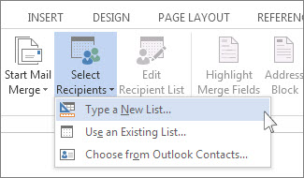
   4. In the **New Address List** dialog box type recipient information in each column as appropriate. For more info on using the dialog box, see Edit Data Souce.
   5. For each new record, select **Add New**.
   6. If you need more columns, such as for an order number, follow these steps:
      1. In the **New Address List** dialog box choose **Customize Columns**.

   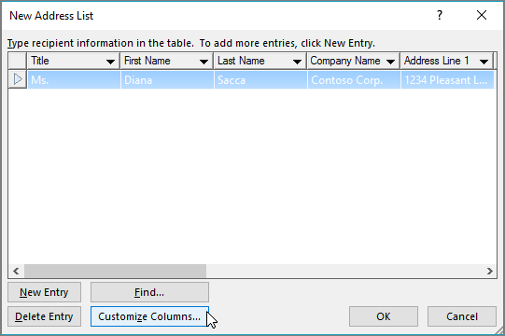

   1. Choose **Add**.

   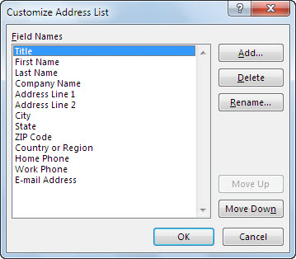

   1. Type a field name and then select OK
      1. 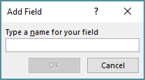
      2. Repeat steps b and c for each column or field to add.
   2. When you're done adding all the people you want to your list, choose **OK**.
   3. In the **Save Address List** dialog box, give your new file a name, and then choose**Save**.

   You can now insert mail merge fields in your document. For more information, see [Insert mail merge fields](https://support.microsoft.com/en-us/office/insert-mail-merge-fields-9a1ab5e3-2d7a-420d-8d7e-7cc26f26acff).

   Collaborative Tools:

   Microsoft Teams is arguably the number 1 collaboration tool available in the Microsoft 365 package. Microsoft Teams enables you to hold video conferences, which is one of the next best ways to have face-to-face interaction if you're unable to meet in person. Microsoft Teams is arguably the number 1 collaboration tool available in the Microsoft 365 package. Microsoft Teams enables you to hold video conferences, which is one of the next best ways to have face-to-face interaction if you're unable to meet in person.

   **Collaborate in Word :**

   * Select Share. on the ribbon. Or, select File > Share. Note: If your file is not already saved to OneDrive, you'll be prompted to upload your file to OneDrive to share it.
   * Select who you want to share with from the drop-down, or enter a name or email address.
   * Add a message (optional) and select Send.

   **Comments to collaborate on Microsoft Word documents:**

   * Create a document thread by selecting the text you want to comment on and clicking Ctrl+Alt+M.
   * Type the comment then click Post.
   * Select any comment in the document to put it into focus and highlight the content it is referencing.

   Document Protection :

   1. Go to File > Info > Protect Document > Encrypt with Password.
   2. Type a password, press OK, type it again and press OK to confirm it.
   3. Save the file to make sure the password takes effect.

   Editing permissions :

   Open the document and click on the "Review" tab. Under "Protect," select "Editing restrictions" to open the editing permissions menu. To restrict editing for the entire document, select the check box next to the words "Allow only this type of editing in the document

   Lab 8

   Introduction to Excel :

   *Excel is a*[*spreadsheet*](https://www.techtarget.com/whatis/definition/spreadsheet)*program from Microsoft and a component of its Office product group for business applications. Microsoft Excel enables users to format, organize and calculate data in a spreadsheet.*

   *By organizing data using software like Excel, data analysts and other users can make information easier to view as data is added or changed. Excel contains a large number of boxes called cells that are ordered in rows and columns. Data is placed in these cells.*

   *Excel is a part of the Microsoft Office and*[*Office 365 suites*](https://www.techtarget.com/searchenterprisedesktop/definition/Microsoft-Office-365-suite)*and is compatible with other applications in the Office suite. The spreadsheet software is available for Windows, macOS, Android and iOS platforms.*[*https://d13ot9o61jdzpp.cloudfront.net/images/10\_int\_functions\_1.png*](https://d13ot9o61jdzpp.cloudfront.net/images/10_int_functions_1.png)

   ## Common Excel use cases :

   * *Excel is most commonly used in business settings. For example, it is used in business analysis,*[*human resource management*](https://www.techtarget.com/searchhrsoftware/definition/human-resource-management-HRM)*, operations management and performance reporting. Excel uses a large collection of cells formatted to organize and manipulate data and solve mathematical functions. Users can arrange data in the spreadsheet using graphing tools,*[*pivot tables*](https://searchsqlserver.techtarget.com/definition/pivot-table)*and formulas. The spreadsheet application also has a macro programming language called Visual Basic for Applications*.

   |  |  |
   | --- | --- |
   | **Function** | **Description** |
   | [=AND](https://www.w3schools.com/excel/excel_and.php) | Returns TRUE or FALSE based on two or more conditions |
   | [=AVERAGE](https://www.w3schools.com/excel/excel_average.php) | Calculates the average (arithmetic mean) |
   | [=AVERAGEIF](https://www.w3schools.com/excel/excel_averageif.php) | Calculates the average of a range based on a TRUE or FALSE condition |
   | [=AVERAGEIFS](https://www.w3schools.com/excel/excel_averageifs.php) | Calculates the average of a range based on one or more TRUE/FALSE conditions |
   | [=CONCAT](https://www.w3schools.com/excel/excel_concat.php) | Links together the content of multiple cells |
   | [=COUNT](https://www.w3schools.com/excel/excel_count.php) | Counts cells with numbers in a range |
   | [=COUNTA](https://www.w3schools.com/excel/excel_counta.php) | Counts all cells in a range that has values, both numbers and letters |
   | [=COUNTBLANK](https://www.w3schools.com/excel/excel_countblank.php) | Counts blank cells in a range |
   | [=COUNTIF](https://www.w3schools.com/excel/excel_countif.php) | Counts cells as specified |
   | [=COUNTIFS](https://www.w3schools.com/excel/excel_countifs.php) | Counts cells in a range based on one or more TRUE or FALSE condition |
   | [=IF](https://www.w3schools.com/excel/excel_if.php) | Returns values based on a TRUE or FALSE condition |
   | [=IFS](https://www.w3schools.com/excel/excel_ifs.php) | Returns values based on one or more TRUE or FALSE conditions |
   | [=LEFT](https://www.w3schools.com/excel/excel_left.php) | Returns values from the left side of a cell |
   | [=LOWER](https://www.w3schools.com/excel/excel_lower.php) | Reformats content to lowercase |
   | [=MAX](https://www.w3schools.com/excel/excel_max.php) | Returns the highest value in a range |
   | [=MEDIAN](https://www.w3schools.com/excel/excel_median.php) | Returns the middle value in the data |
   | [=MIN](https://www.w3schools.com/excel/excel_min.php) | Returns the lowest value in a range |
   | [=MODE](https://www.w3schools.com/excel/excel_mode.php) | Finds the number seen most times. The function always returns a single number |
   | [=NPV](https://www.w3schools.com/excel/excel_npv.php) | The NPV function is used to calculate the Net Present Value (NPV) |
   | [=OR](https://www.w3schools.com/excel/excel_or.php) | Returns TRUE or FALSE based on two or more conditions |
   | [=RAND](https://www.w3schools.com/excel/excel_rand.php) | Generates a random number |
   | [=RIGHT](https://www.w3schools.com/excel/excel_right.php) | Returns values from the right side of a cell |
   | [=STDEV.P](https://www.w3schools.com/excel/excel_stdevp.php) | Calculates the Standard Deviation (Std) for the entire population |
   | [=STDEV.S](https://www.w3schools.com/excel/excel_stdevs.php) | Calculates the Standard Deviation (Std) for a sample |
   | [=SUM](https://www.w3schools.com/excel/excel_sum.php) | Adds together numbers in a range |
   | [=SUMIF](https://www.w3schools.com/excel/excel_sumif.php) | Calculates the sum of values in a range based on a TRUE or FALSE condition |
   | [=SUMIFS](https://www.w3schools.com/excel/excel_sumifs.php) | Calculates the sum of a range based on one or more TRUE or FALSE condition |
   | [=TRIM](https://www.w3schools.com/excel/excel_trim.php) | Removes irregular spacing, leaving one space between each value |
   | [=VLOOKUP](https://www.w3schools.com/excel/excel_vlookup.php) | Allows vertical searches for values in a table |
   | [=XOR](https://www.w3schools.com/excel/excel_xor.php) | Returns TRUE or FALSE based on two or more conditions |

   **In Excel:**

   * Click on the first sheet tab you want to include.
   * Hold down the Ctrl key and click on the other sheet tabs you want to include (or Shift for a range).
   * Enter your function or formula in the desired cell on the active sheet. This change will be applied to the same cell in all s.

   **Cell referencing :**

   Cells are the boxes you see in the grid of an Excel worksheet, like this one. Each cell is identified on a worksheet by its reference, the column letter and row number that intersect at the cell's location. This cell is in column D and row 5, so it is cell D5. The column always comes first in a cell reference.

   Excel's Cell Reference Types

   Relative A1

   Absolute $A$1

   Mixed $A1 or A$1

   **Sorting Data**

   1. *Under Column, choose the first column that you would like to sort. If you want to sort multiple columns, click the Add Level button.*
   2. *Under Sort On, choose how you would like to sort. ...*
   3. *Under Order, choose A to Z (ascending), Z to A (descending), or Custom List.*

   *Click OK to perform the sort.*

   **Data Filtering :**

   Data filtering is the process of examining a dataset to exclude, rearrange, or apportion data according to certain criteria. For example, data filtering may involve finding out the total number of sales per quarter and excluding records from last month.

   LAB 9

   **Data Visualization :**

   Data visualizations in Excel are representations of numerical data in a visual format. You can organize data in a spreadsheet into a more accessible and organized format like a line graph, Gantt chart or bar graph.

   **Best Advanced Graphs in Excel :**

   * *Sankey Diagram. The Sankey Diagram is a powerful tool for visualizing flows and relationships between different elements. ...*
   * *Likert Scale Chart. ...*
   * *Comparison Bar Chart. ...*
   * *Gauge Chart. ...*
   * *Multi-Axis Line Chart. ...*
   * *Sunburst Chart. ...*
   * *Radar Chart. ...*
   * *Radial Bar Chart.*

   Conditional Formatting :

   Select the range of cells, the table, or the whole sheet that you want to apply conditional formatting to. On the Home tab, click Conditional Formatting. Click New Rule. Select a style, for example, 3-Color Scale, select the conditions that you want, and then click OK

   . **To create QR code :**

   1. *Generate. Open the QR code generator, enter a URL, and tap the Download button. ...*
   2. *Personalize. Customize the style and color of your free generated QR code to match your branding.*
   3. *Continue editing. Download the QR code image in your preferred file type.*

   **To create a barcode :**

   1. *Select the barcode type: EAN-13, UPC-A, Code 39, or ITF.*
   2. *Fill in the product category information in the barcode data box.*
   3. *Click on the barcode title box and barcode note if you want to add them in the barcode.*
   4. *Add a name for the barcode in the title box and more details in the note box.*

   **Data Validation** **:**

   You can use data validation to restrict the type of data or values that users enter into cells. For example, you might use data validation to calculate the maximum allowed value in a cell based on a value elsewhere in the workbook.

   Working with Tables :

   A data table is a range of cells in which you can change values in some of the cells and come up with different answers to a problem. A good example of a data table employs the PMT function with different loan amounts and interest rates to calculate the affordable amount on a home mortgage loan.

   **Frequency Function :**

   The FREQUENCY function calculates how often values occur within a range of values, and then returns a vertical array of numbers. For example, use FREQUENCY to count the number of test scores that fall within ranges of scores. Because FREQUENCY returns an array, it must be entered as an array formula.

   ## Example :

   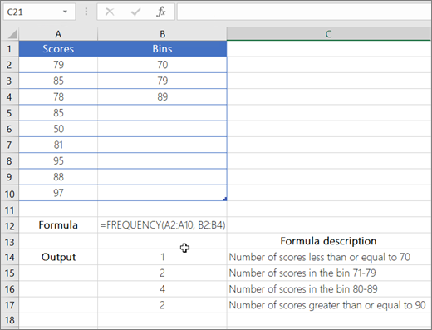

   Statistical Function :

   Excel's statistical functions provide a range of tools for data analysis. Functions like AVERAGE, COUNT, SUM, MIN, MAX, MEDIAN, MODE, STDEV, VAR, and more help calculate descriptive statistics.

   LAB 10

   Pivot Table :

   A PivotTable is an interactive way to quickly summarize large amounts of data. You can use a PivotTable to analyze numerical data in detail, and answer unanticipated questions about your data. A PivotTable is especially designed for: Querying large amounts of data in many user-friendly ways.

   ***VLOOKUP in Excel :***

   1. Identify a column of cells you'd like to fill with new data.
   2. Select 'Function' (Fx) > VLOOKUP and insert this formula into your highlighted cell.
   3. Enter the lookup value for which you want to retrieve new data.
   4. Enter the table array of the spreadsheet where your desired data is located.

   Example 1:

   =VLOOKUP (B3,B2:E7,2,FALSE)

   VLOOKUP looks for Fontana in the first column (column B) in the table_array B2:E7, and returns Olivier from the second column (column C) of the table_array.  False returns an exact match.

   ***Hlook up in excel :***

   1. The HLOOKUP function can only search in the **top-most row** of table\_array. If you need to look up somewhere else, consider using an [Index / Match formula](https://www.ablebits.com/office-addins-blog/excel-hlookup-formula-examples/#index-match-alternative-to-hlookup).
   2. HLOOKUP in Excel is **case-insensitive**, it does not distinguish uppercase and lowercase.
   3. If range\_lookup is set to TRUE or omitted (**approximate** match), the values in the first row of table\_array must be sorted in **ascending order** (A-Z) left to right.

   Example

   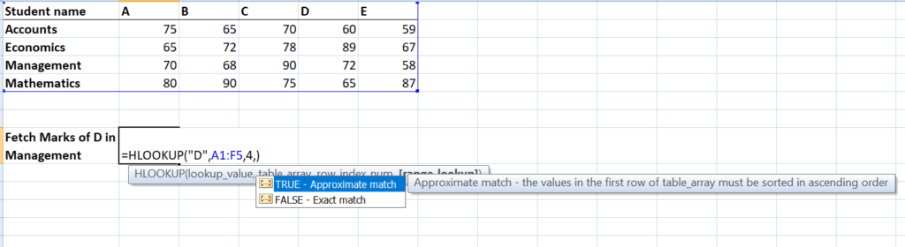

   The result would be 72.

   ***HISTORY OF MACRO :***

   Ragnar Frich

   The term microeconomics and macroeconomics was first coined by a Norwegian economist, Ragnar Frich in 1993. Microeconomics is the branch of economics that focuses on the actions of individuals and industries. Macroeconomics is the branch of economics that researches the behavior of an economy as a whole.

   ***MACRO :***

   *A macro is a series of commands and actions that can be stored and run whenever you need to perform a computer task. Use macros to automate actions that you perform repeatedly or on a regular basis*.

   ***Record a macro with a button:***

   * Click View > Macros > Record Macro.
   * Type a name for the macro.
   * To use this macro in any new documents you make, be sure the Store macro in box says All Documents (Normal. ...
   * To run your macro when you click a button, click Button.
   * Click the new macro (it's named something like Normal.

   [↑](#endnote-ref-2)